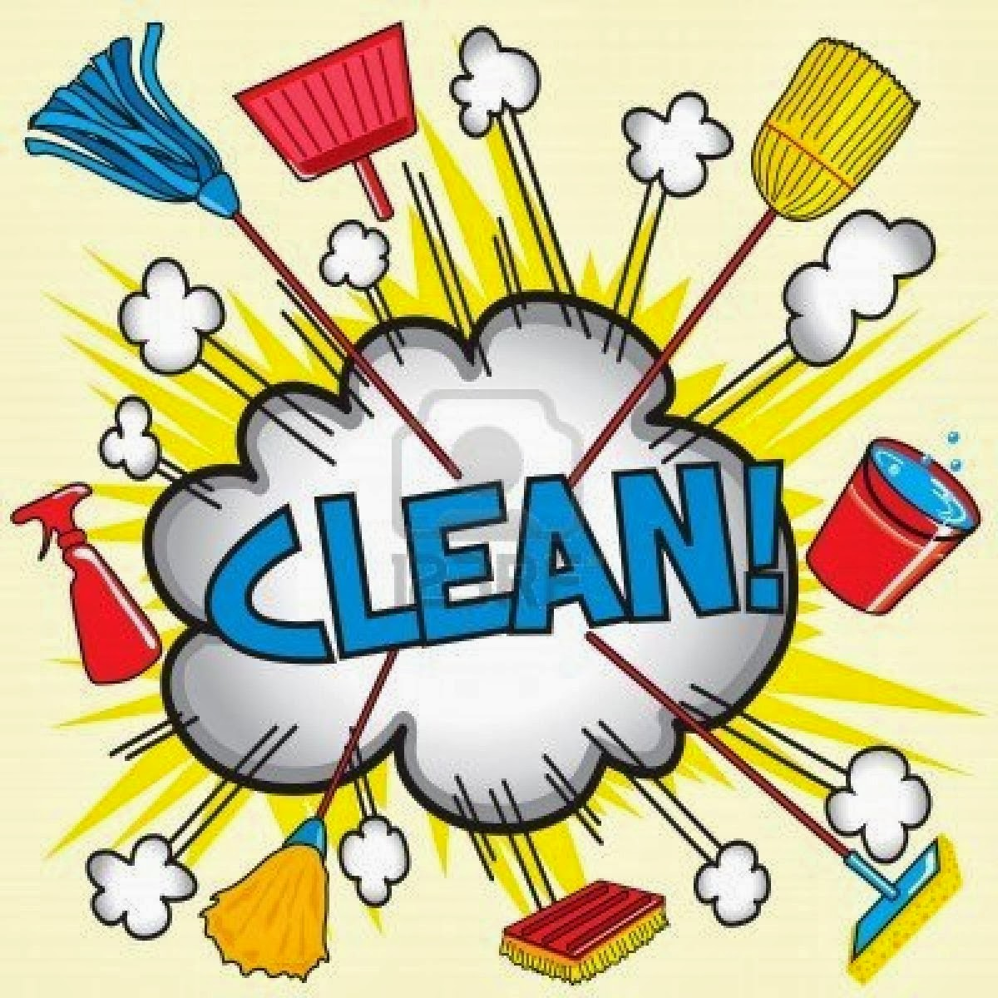

READING TOWNSHIP SPRING CLEAN UP
Saturday, April 26th, 8:00 am - 3:00 pm
ONE DAY ONLY
ID is required when bringing items to Township
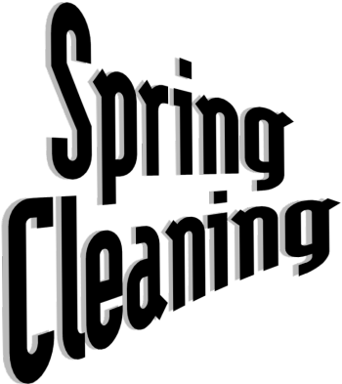
Residents of Reading Township may bring items for disposal to the Township Building, 50 Church Road, East Berlin. Free permits are required from the Township Office Monday-Thursday, 8:00 am – 3:30 pm. One pick-up truck or 5x7 utility trailer allowed per household. Small materials must be boxed or bundled.
Accepted Items: Household items and appliances with doors removed from freezers & refrigerators, sealed paint cans, wire fencing and batteries. Electronics are not accepted at this event. There will be a separate day scheduled in the future for electronics only. Tires on the rims $11.00 and paid at drop off: $3.00 for small residential tires up to 18” maximum. Tires over 18” will no longer be accepted.

Items not accepted: Pesticides, cement, roofing materials, brush, tires over 18” or items for regular trash collection.

